Practical 1
Objective:
Create two webpages, "Hobbies" and "Education," that utilize the HTML concepts covered in the lecture slides, focusing on HTML elements, image maps, and tables. No need CSS for this lab.
Part 1: Hobbies Webpage
Create a folder called labno_yourname_WP01
Task 1.1: Basic HTML Structure
- Create a new HTML file named hobbies.html.
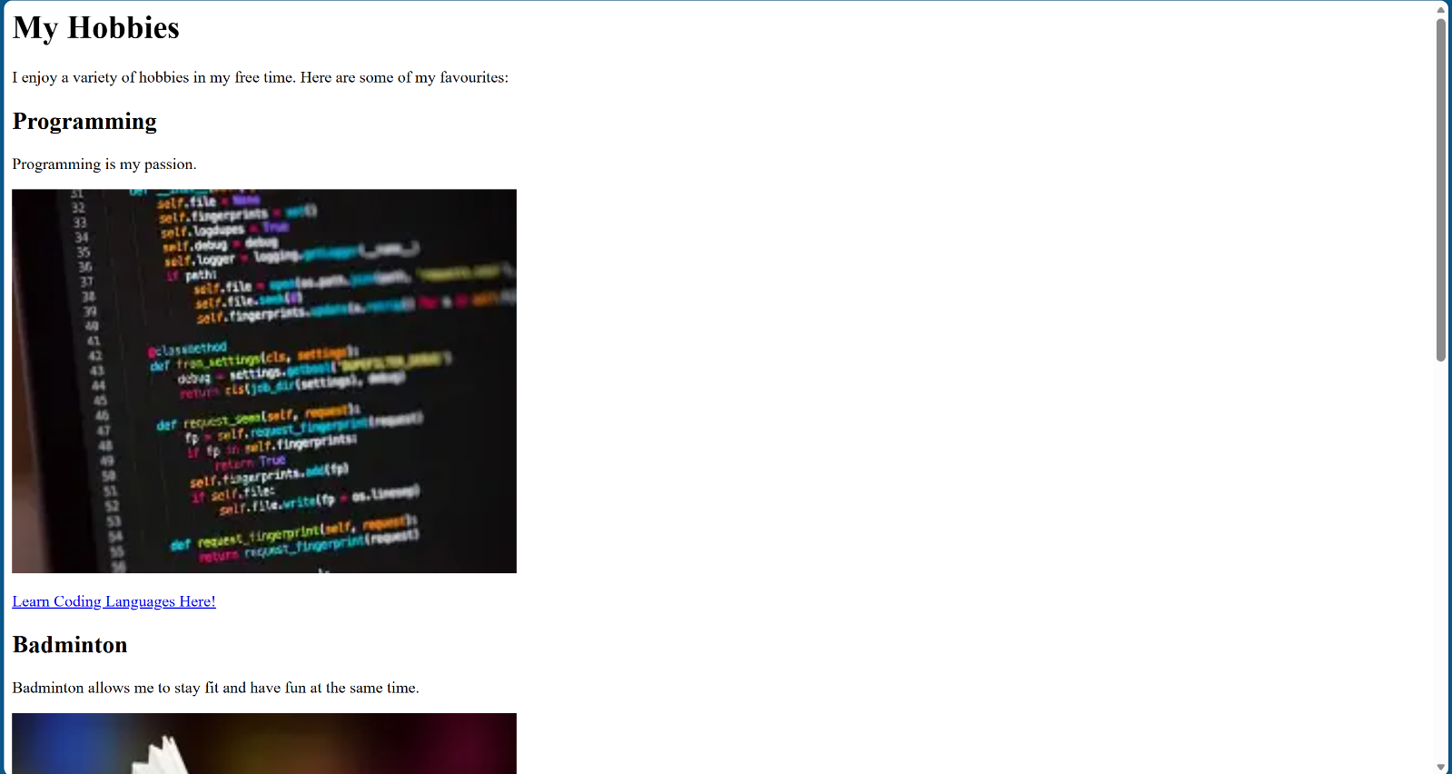
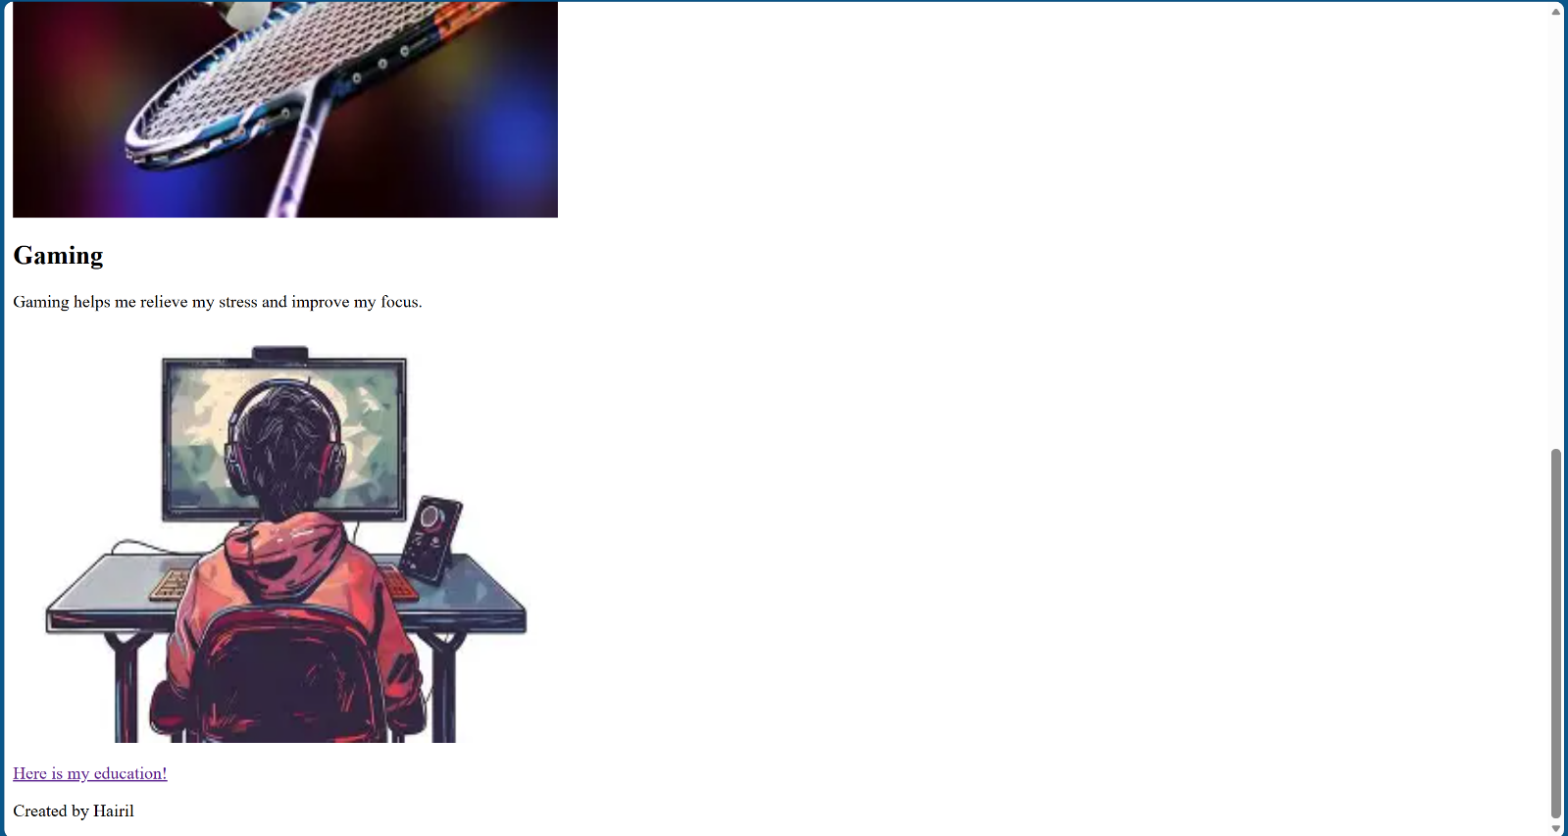
Task 1.2: Adding Images
- Add images related each of your hobbies within the corresponding article.
- Use the src, alt, title, height, and width attributes for the image.
- Download image files and put in folder called images.

Task 1.3: Hyperlinks
- Add a hyperlink to an external website related to one of your hobbies.
- Add a hyperlink to the "Education" page you will create next.

Task 1.4: Image Map
- Use image map for one of your hobbies, creating clickable areas that link to at least 3 different external websites. [Use this visual tool to help: https://www.image-map.net/]
Example:
One of your hobbies is overseas travel. Use world map as image map and allow hotspots (clickable areas of those countries you been. E.g. click on Australia are to launch Australia website.
https://www.mapsofworld.com/style_2019/images/world-map.png
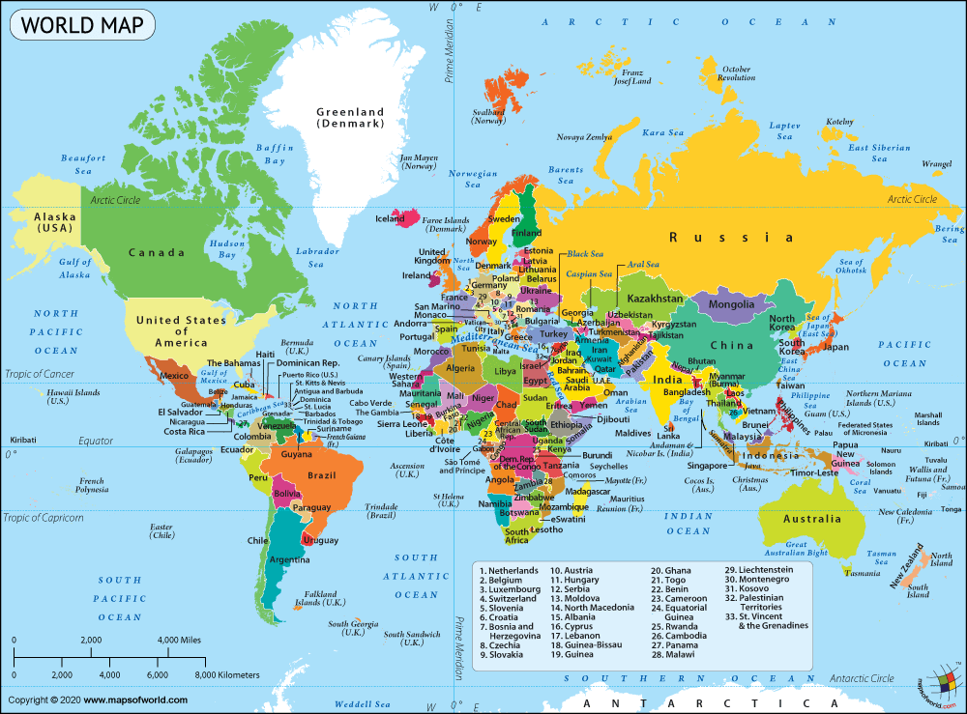
-------------Hobbies.html source code start-------------
<html lang="en">
<head>
<title>Practical 01</title>
</head>
<body>

<h1>My Hobbies </h1>
<p>I enjoy a variety of hobbies in my free time. Here are some of my favourites: </p>

<h2>Programming </h2>
<p>Programming is my passion. </p>
<img src="images/programming.webp" alt="programming" title="Programming" width="500" height="380">
<br></br>
<a href="https://www.w3schools.com">Learn Coding Languages Here!</a>

<h2>Badminton </h2>
<p>Badminton allows me to stay fit and have fun at the same time. </p>
<img src="images/badminton.webp" usemap="#badminton" alt="someone playing badminton" title="Badminton" width="500" height="380">

<h2>Gaming </h2>
<p>Gaming helps me relieve my stress and improve my focus. </p>
<img src="images/gaming.webp" alt="a person playing a game" title="Gaming" width="500" height="380">

<map name="badminton">

<area shape="rect" coords="100, 100, 170, 160" alt="Shuttle" target="_blank" href="https://www.bing.com/ck/a?!&&p=99b0bc78ab4ad5e05698bf8ef20479af57a9aa266ec557a1734f9a4035b928a3JmltdHM9MTc3NjgxNjAwMA&ptn=3&ver=2&hsh=4&fclid=01306a19-2090-6fff-229c-7d5d217d6e14&psq=shuttlecock&u=a1aHR0cHM6Ly9lbi53aWtpcGVkaWEub3JnL3dpa2kvU2h1dHRsZWNvY2s">

<area shape="rect" coords="300, 190, 350, 240" alt="racket" target="_blank" href="https://www.bing.com/ck/a?!&&p=8b10f82b9bdbedb21b5e4f05c9ccdb427051947fb60289e2629cb7c59233489dJmltdHM9MTc3NjgxNjAwMA&ptn=3&ver=2&hsh=4&fclid=01306a19-2090-6fff-229c-7d5d217d6e14&psq=racket+badminton&u=a1aHR0cHM6Ly93d3cuZGVjYXRobG9uLnNnL2MvcmFja2V0LXNwb3J0cy9iYWRtaW50b24vcmFja2V0cy5odG1s">

<area shape="rect" coords="25, 25, 50, 50" alt="secret" target="_blank" href="https://www.bing.com/ck/a?!&&p=a708db25c458f1d27b7751625b3631085e119d9f5db1c673d6999dd1f1c82b60JmltdHM9MTc3NjgxNjAwMA&ptn=3&ver=2&hsh=4&fclid=01306a19-2090-6fff-229c-7d5d217d6e14&psq=mcdonald%27s&u=a1aHR0cHM6Ly93d3cubWNkb25hbGRzLmNvbS5zZy8">

</map>

<br></br>
<a href="education.html">Here is my education!</a>

<p>Created by Hairil </p>

</body>
</html>
-------------Hobbies.html source code end-------------
Part 2: Education Webpage
Task 2.1: Basic HTML Structure
- Create a new HTML file named education.html.
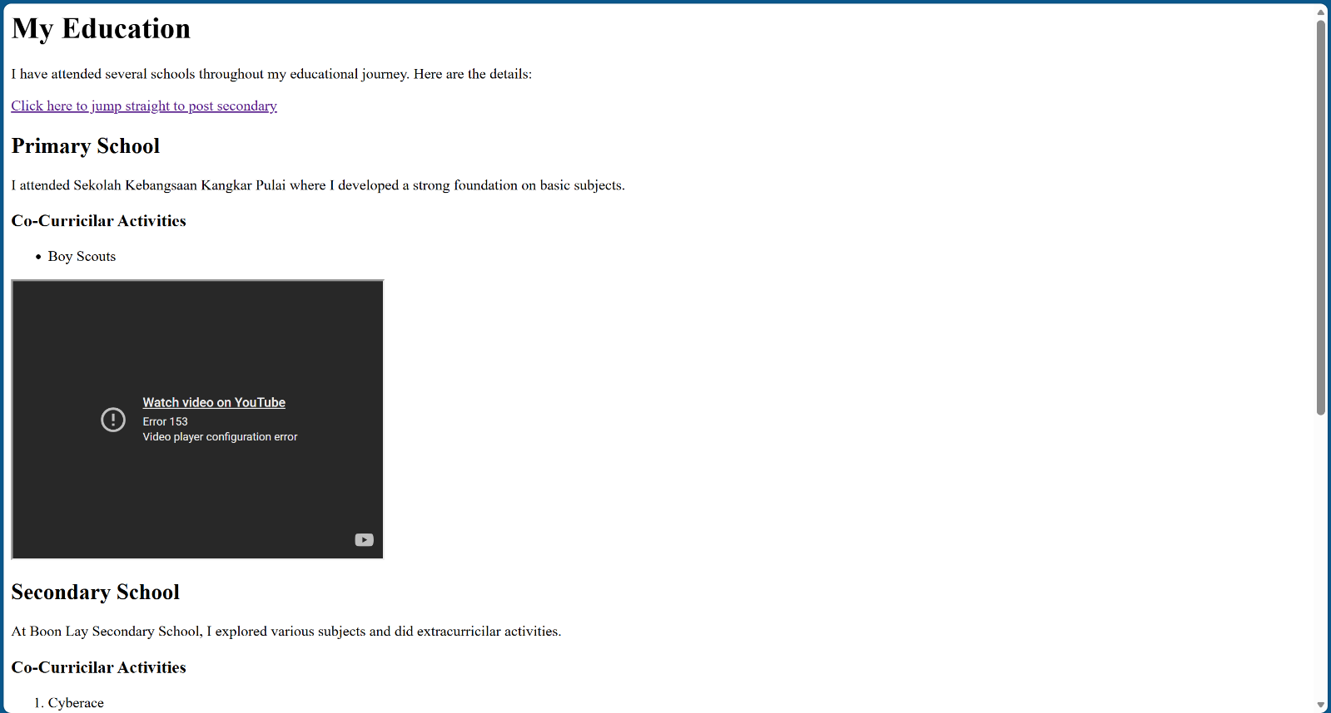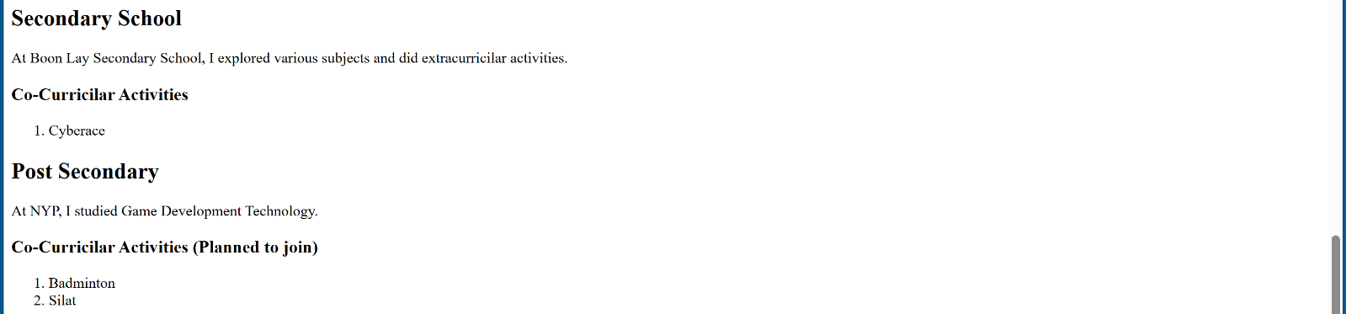
Task 2.2: Embedding Videos
- Embed a video related to education or a subject or CCA under the paragraph.
Task 2.3: Internal Links and Comments
- Add an internal link that jumps to a specific section within the same page (e.g from bottom of page to return to top)
- Add comments in your HTML code to explain different sections.

Task 2.4: HTML Tables
- Add a HTML table to show your current NYP Timetable.
- Use appropriate table tags (<table border>, <tr>, <th>, <td>).
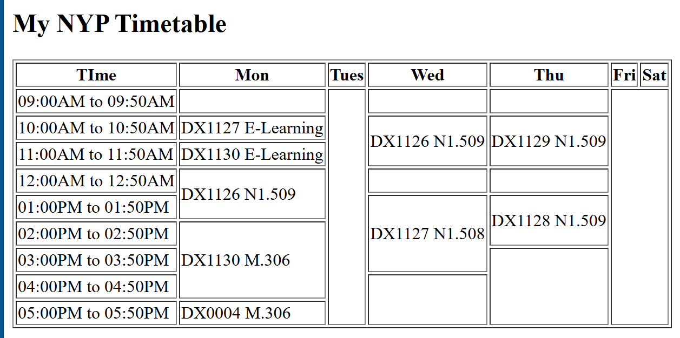
Challenge: Combining Common slots (using rowspan and colspan)
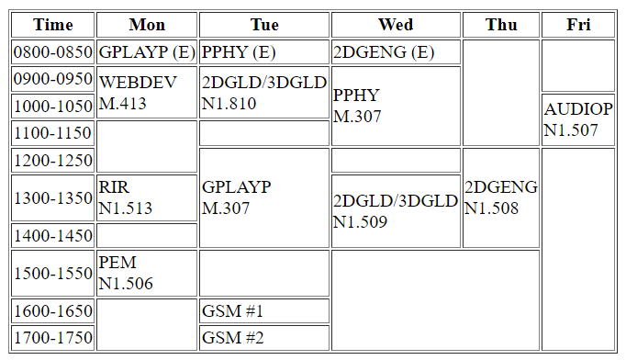
-------------Education.html source code start-------------
<html>

<head>
<title>Education Page</title>
</head>
<body>
<h1>My Education</h1>
<p>I have attended several schools throughout my educational journey. Here are the details: </p>
<a href="#post">Click here to jump straight to post secondary</a> <!-- When clicked, the visitor will go straight to the post secondary section -->

<h2>Primary School</h2>
<p>I attended Sekolah Kebangsaan Kangkar Pulai where I developed a strong foundation on basic subjects. </p>
<h3>Co-Curricilar Activities</h3>
<ul>
<li>Boy Scouts</li>
</ul>
<iframe height="300" width="400" src="https://www.youtube.com/embed/z0-ZhYEsC6s"></iframe>

<h2>Secondary School</h2>
<p>At Boon Lay Secondary School, I explored various subjects and did extracurricilar activities.</p>
<h3>Co-Curricilar Activities</h3>
<ol>
<li>Cyberace</li>
</ol>

<h2 id="post">Post Secondary</h2>
<p>At NYP, I studied Game Development Technology. </p>
<h3>Co-Curricilar Activities (Planned to join)</h3>
<ol>
<li>Badminton</li>
<li>Silat</li>
</ol>

<h2>My NYP Timetable</h2>
<table border="1">
<tr>
<th>TIme</th><th>Mon</th><th>Tues</th><th>Wed</th><th>Thu</th><th>Fri</th><th>Sat</th>
</tr>
<tr>
<td>09:00AM to 09:50AM</td><td></td><td rowspan="9"></td><td></td><td></td><td rowspan="9"></td><td rowspan="9"></td>
</tr>
<tr>
<td>10:00AM to 10:50AM</td><td>DX1127 E-Learning</td><td rowspan="2">DX1126 N1.509</td><td rowspan="2">DX1129 N1.509</td>
</tr>
<tr>
<td>11:00AM to 11:50AM</td><td>DX1130 E-Learning</td>
</tr>
<tr>
<td>12:00AM to 12:50AM</td><td rowspan="2">DX1126 N1.509</td><td></td><td></td>
</tr>
<tr>
<td>01:00PM to 01:50PM</td><td rowspan="3">DX1127 N1.508</td><td rowspan="2">DX1128 N1.509</td>
</tr>
<tr>
<td>02:00PM to 02:50PM</td><td rowspan="3">DX1130 M.306</td>
</tr>
<tr>
<td>03:00PM to 03:50PM</td><td rowspan="3"></td>
</tr>
<tr>
<td>04:00PM to 04:50PM</td><td rowspan="2"></td>
</tr>
<tr>
<td>05:00PM to 05:50PM</td><td>DX0004 M.306</td>
</tr>
</table>

<p>Created by Hairil</p>

</body>
<html>
-------------Education.html source code end-------------

Final Task
Task 3.1: HTML Validation
- Validate your HTML code using the W3C Markup Validation Service. https://validator.w3.org/#validate_by_input
- Fix any errors or warnings that are identified.
--------validation results start-------------
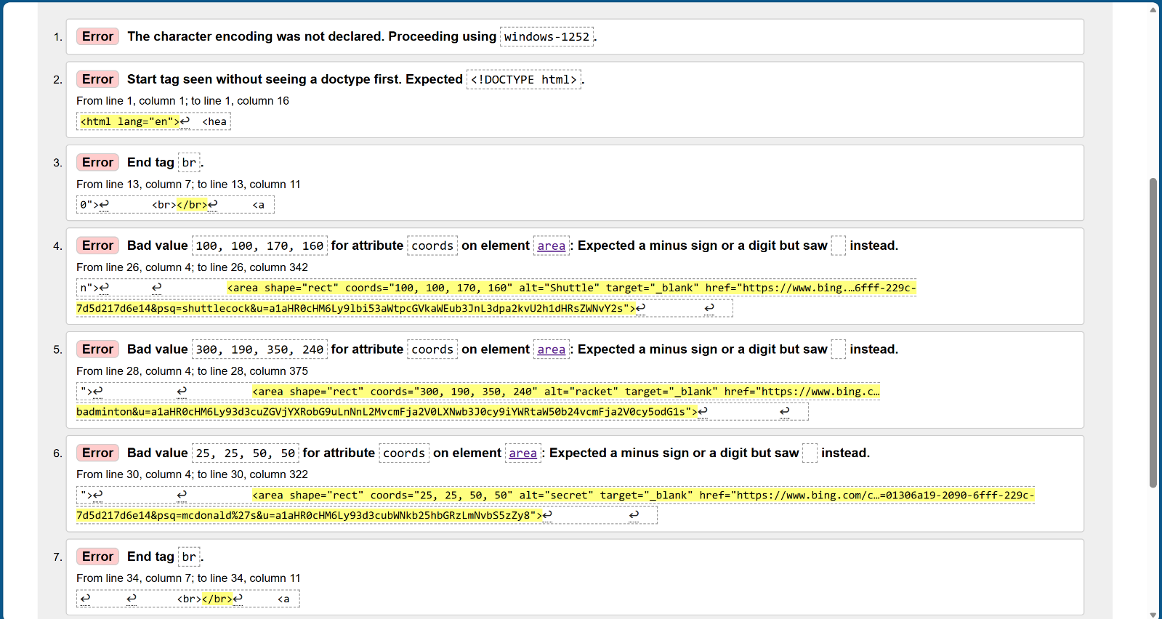
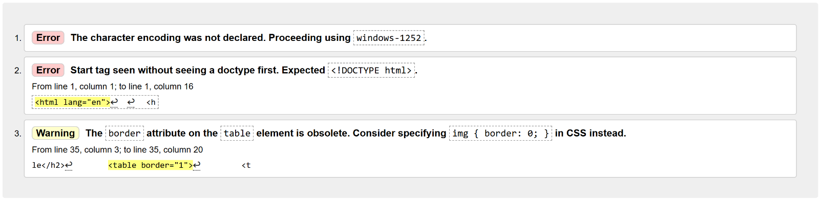

--------validation results end-------------

